**Practical-7 Thread management using posix api**

**Code:**

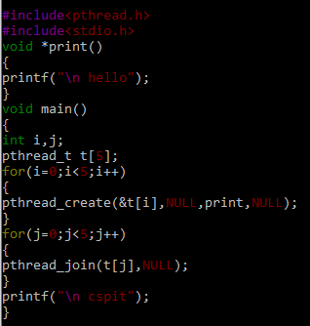

**Output:**

